

**Google Ads Web Conversion Tracking - Browser and Server**

**Google Ads Attribution Models**

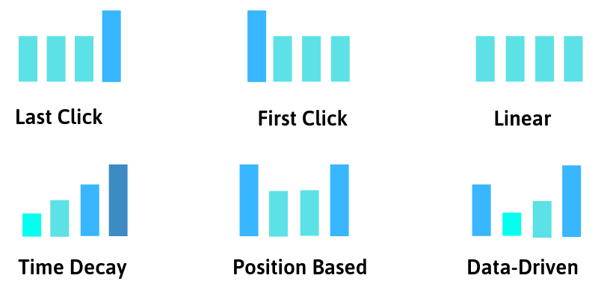

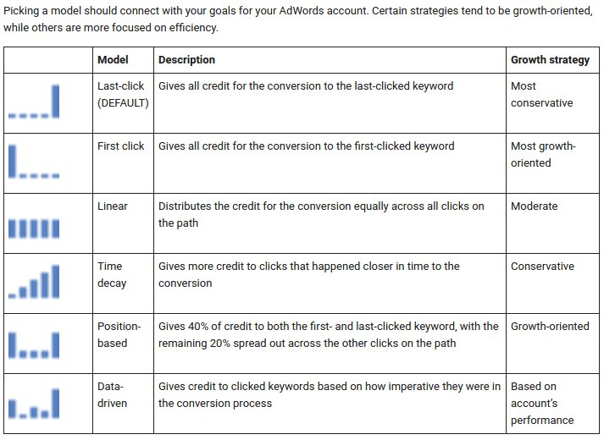

T-Shirt - dm-analytics.com/products/t-shirt

Campaign - 1 - PPC

Campaign - 2 - Display

Campaign - 3 - Youtube Video

Purchase is our main conversion